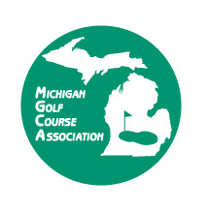

*2023 Matthews Lifetime Achievement Award*

Nomination Form

***Matthews Lifetime Achievement Award*** *is presented to an individual or organization that over the span of a lifetime has provided steadfast leadership, outstanding service, and continuous commitment to the Michigan golf industry. The award is named after W. Bruce Matthews, the first award recipient in 1996. Mr. Matthews spread his expertise throughout the fairways of Michigan for many generations.*

Please list the name of the person that you would like to nominate for the Matthews Lifetime Achievement Award.

Name: _________________________________________ Address: ________________________________________

Phone: _______________________________ E mail_____________________________________________________

Please describe why you feel this person should be a candidate for the Matthews Lifetime Achievement Award: (Attach a separate sheet as necessary.)

**Deadline to nominate is October 6, 2023 by 5:00 pm.** The 2023 Matthews Lifetime Achievement Award Winner will be honored at the Michigan Golf Business Conference Award Winners Banquet on Tuesday, November 28, 2023 at FireKeepers Casino & Hotel, Battle Creek.

Contact information for person making nomination:

Name: ______________________________ Phone: ___________________ Email:____________________________

Email completed nomination form to:

Jada Paisley at [jpaisley@michigangca.org](mailto:jpaisley@michigangca.org) or mail to MGCA 1005 Abbot Rd., Ste. A, East Lansing, MI 48823

or FAX (517) 267-8984. If you have any questions, please call Jada at 800-860-8575.